**SDF-TUT-1_20103153**

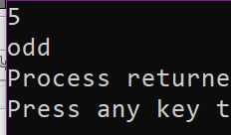**Q1.**

#include<iostream>

using namespace std;

int main()

{

int n;

cin>>n;

if(n%2==0)

cout<<"even";

else cout<<"odd";

}

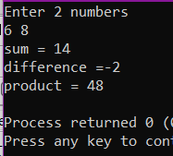**Q2.**

#include<iostream>

#include <cstdio>

using namespace std;

int main()

{

int a,b,sum,diff,prod;

cout<<"Enter 2 numbers"<<endl;

cin>>a>>b;

cout<<"sum = "<<a+b<<endl;

cout<<"difference ="<<a-b<<endl;

cout<<"product = "<<a*b<<endl;

}

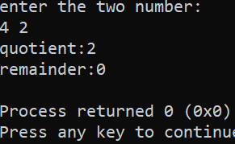**Q3.**

#include <iostream>

using namespace std;

int main()

{

int a,b;

cout <<"enter the two number:" << endl;

cin >> a >> b;

if (b ==0)

{

cout <<"not possible" << endl;

}

else

{

cout <<"quotient:" << a/b << endl;

cout <<"remainder:" << a%b << endl;

}

return 0;

}

**Q4.**

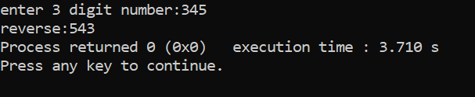#include<iostream>

using namespace std;

int main()

{

int n,rev=0,r;

cout<<"enter 3 digit number:";

cin>>n;

while(n>0)

{

r=n%10;

rev=rev*10+r;

n=n/10;

}

cout<<"reverse:"<<rev;

return 0;

}

**Q5.**

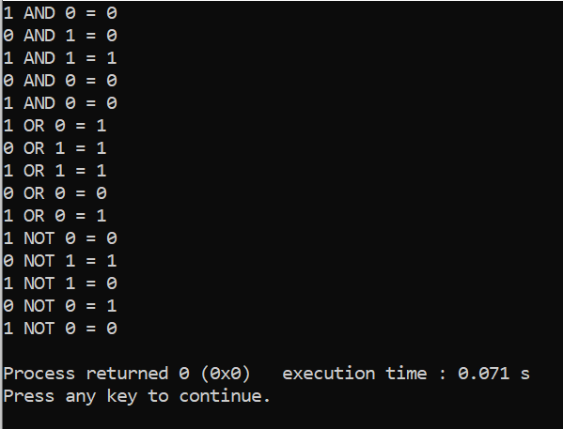#include <iostream>

using namespace std;

int main()

{

int a[5] = { 1, 0, 1, 0, 1 };

int b[5] = { 0, 1, 1, 0, 0 };

int i, p, ans, result;

for (i = 0; i < 5; i++) {

p = a[i] * b[i];

cout << a[i] << " AND " << b[i] << " = " << p << endl;

}

for (i = 0; i < 5; i++) {

if (a[i] + b[i] > 0)

ans = 1;

else

ans = 0;

cout << a[i] << " OR " << b[i] << " = " << ans << endl;

}

for (i = 0; i < 5; i++) {

if (a[i] == 0)

result = 1;

else

result = 0;

cout << a[i] << " NOT " << b[i] << " = " << result << endl;

}

return 0;

}

**Q6.**

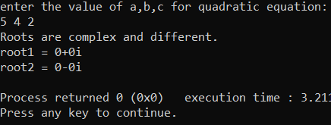#include <iostream>

#include<cmath>

using namespace std;

int main()

{ int a,b,c ,d,r1,r2, realPart, imaginaryPart ;

cout << "enter the value of a,b,c for quadratic equation:" << endl;

cin >> a >> b >> c;

d = b*b - 4*a*c;

if(d==0)

{

r1=r2= -b/(2*a);

cout << "both the same roots are :" << r1;

}

else if (d>0)

{

r1 = (-b + sqrt(d)) / (2*a);

r2 = (-b - sqrt(d)) / (2*a);

cout << "Roots are real and different." << endl;

cout << "root1 = " << r1 << endl;

cout << "root2 = " << r2 << endl;

}

else {

realPart = -b/(2*a);

imaginaryPart =sqrt(-d)/(2*a);

cout << "Roots are complex and different." << endl;

cout << "root1 = " << realPart << "+" << imaginaryPart << "i" << endl;

cout << "root2 = " << realPart << "-" << imaginaryPart << "i" << endl;

}

return 0;

}

**Q7.**

#include<iostream>

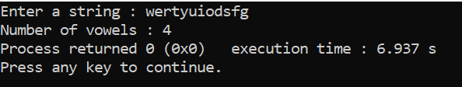using namespace std;

int main ()

{

char str[50];

int v = 0;

cout << "Enter a string : ";

gets(str);

for (int i = 0; str[i]!='\0'; ++i)

{

if (str[i] == 'a' || str[i] == 'e' || str[i] == 'i' || str[i] == 'o' || str[i] == 'u' || str[i] == 'A' || str[i] == 'E' || str[i] == 'I' || str[i] == 'O' || str[i] == 'U')

++v;

}

cout << "Number of vowels : " << v;

return 0;

}

**Q8.**

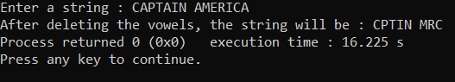#include<iostream>

#include<string.h>

using namespace std;

int main()

{

char str[100];

int i,j,len=0;

cout<<"Enter a string : ";

gets(str);

len=strlen(str);

for(i=0; i<len; i++)

{

if(str[i]=='a'||str[i]=='e'||str[i]=='i'||str[i]=='o'||str[i]=='u'||str[i]=='A'||str[i]=='E'||str[i]=='I'||str[i]=='O'||str[i]=='U')

{

for(j=i; j<len; j++)

{

str[j]=str[j+1];

}

len--;

}

}

cout<<"After deleting the vowels, the string will be : "<<str;

return 0;

}